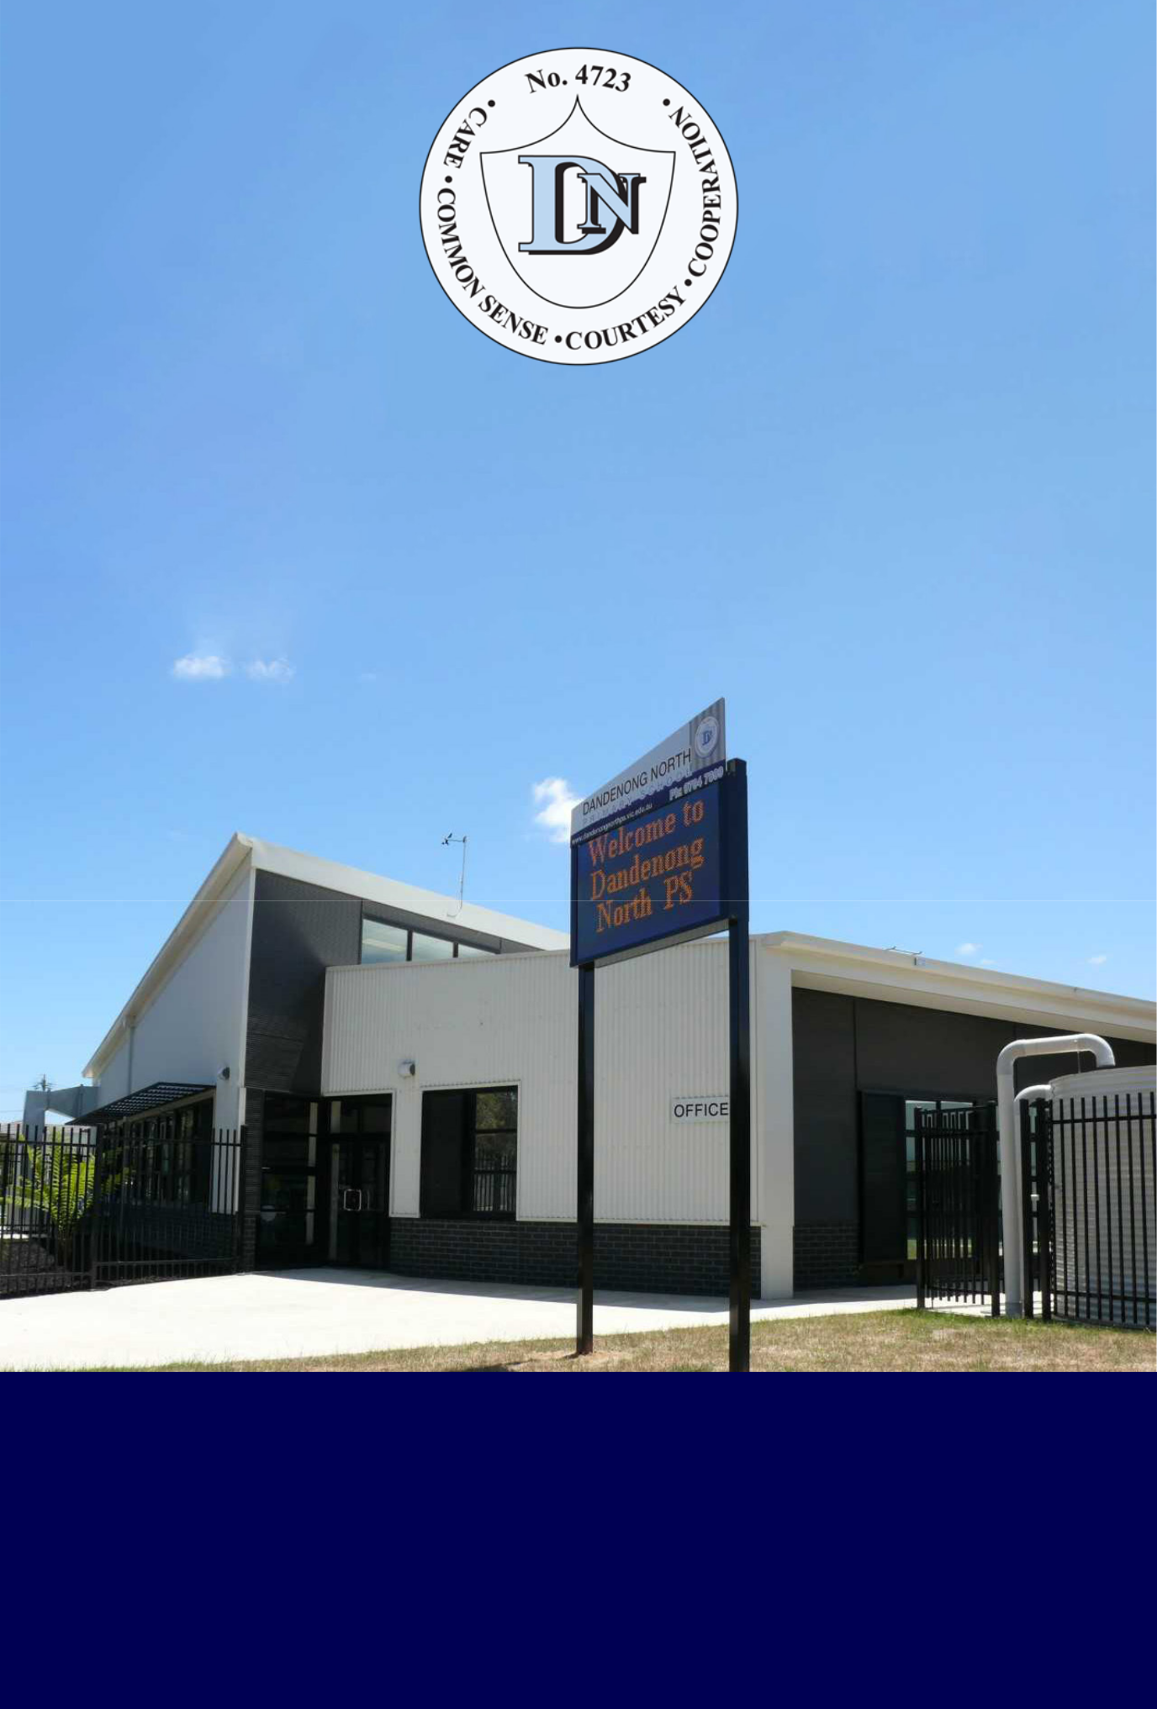

DANDENONG NORTH PRIMARY SCHOOL

FOUNDATION TRANSITION
INFORMATION BOOKLET


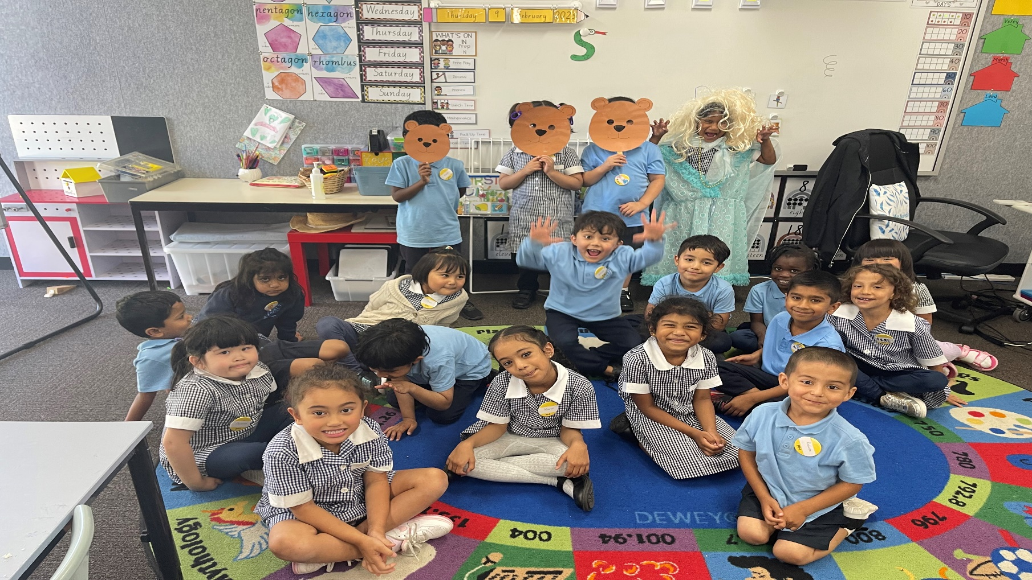
TABLE OF CONTENTS

Absence from school………………………………….....................9 | Newsletters/Notices………………………………………………..12
Assembly Arrangements……………………………………………….12  Before and After School / Out of Hours Care…………………..6 | Parent Helpers…………………………………………………………12  Playground Supervision Before and After School…….12
Bookclub……………………………………………………………………….12 | Private Property…………………………………………..……………12
Booklist…………………………………………………………………………8 | SENTRAL……………………………………………………………………..6
Children’s Progress……………………………………………………….7 | School Council…………………………………………………………13
Code of Conduct…………………………………………………………..7 | School Council Members…………………………………………13
Custody Restrictions/Court Documents………………………..7 | School Hours……………………………………………………………..6
Dental Health Services………………………………………………….10 | School Nursing Service…………………………………………….13
Emergency Contact Information…………………………………..8 | School Profile…………………………………………………………….5
Excursions/Incursions…………………………………………………..8 | Self-Esteem Program……………………………………………….14
Getting To and From School……………………………………….10 | Special Lunches……………………………………………………….11
Head Lice……………………………………………………………………10 | Sun Smart………………………………………………………………..15
Illness…………………………………………………………………………11 | Student Leadership………………………………….……………..14
Immunisation Certicate………………………………………………10 | Swimming Program………………………………………………….12
Infectious Diseases…………………………………………………….11 | Term Dates for Students……………………………………………6
Late Arrival…………………………………………………………………11 | Transferring to New School…………………………………..…12
Leaving School Early…………………………………………………..12 | Uniforms………………………………………………………………….11
Lost Property……………………………………………………………..12 | Welfare…………………………………………………………………...11
Medication………………………….…………………………………...12 | School Council…………………………………………………………13
Money Sent to School……………………………….……………..12 | School Council Members…………………………………………13
Mobile Phones…………………………………..………………………11

DANDENONG NORTH PS CONTACTS

PRINCIPAL

Mr Paul Hilton

ASSISTANT PRINCIPAL
Mrs Erin Scott

WELFARE OFFICER

Miss Sobia Hussain (currently on Maternity Leave)
Mrs Kareen Blachford (Monday and Wednesday)

OFFICE STAFF

Mrs Kristie Miller
Mrs Suzanne Anderson

Miss Josie Kanjer
Mrs Trish Ryan
Mrs Alia Hussain

PHONE
9794 7899

WEBSITE
www.dandenongnorthps.vic.edu.au


SCHOOL PROFILE

Dandenong North Primary is a progressive School of the future situated close to the Dandenong Market. Many families temporarily settle in Dandenong after first arriving in Australia. Other families are well established in this city. Community facilities including extensive sports fields, basketball stadium, indoor swimming complex and Regional Library are located close to the school.

The school atmosphere is welcoming and friendly; it resembles that of a very large family. Using good manners and accepting responsibility are valued. Children are taught to be polite and respectful.

Literacy and numeracy are the priorities of this school. Half of our students fluently speak a language other than English. Many beginning students do not speak any English at all. Our success in developing fluent English speakers within six months of starting school is a measure of our very effective English for Speakers of Other Language (ESOL) program. Vocabulary development and spelling accuracy are given special emphasis. A theme approach is used to integrate other curriculums area with English. Specialist staff implement programs in ICT, the visual arts, sport and physical education.

Children with special needs (including high ability children) have priority access to special needs elective programs. Multi-age classes are favoured. Friendly and skilled teachers, selected on the basis of merit and equity, match program challenges with individual learning needs and abilities.

Student learning is monitored through tests at the beginning and end of units and student work samples are used to determine progress. There are twice-yearly written reports in June and December, parent/teacher interviews are held in June.

Staff trained in First Aid are readily available.

The sport and physical education program is viewed as very important. Team participation is encouraged and supported through Gala days at a Year 6 level. Teams train at lunch times or after school. The well-maintained buildings of the school environment include a well equipped new gymnasium and hall, library, art room, computer facilities, large meeting room and ample learning spaces.

Children take responsibility for the whole school assemblies and present daily public address bulletins. Junior School Council decisions contribute to the sharing of democratic responsibility for learning. Care, courtesy, co-operation and common sense (the 4 C’s) are what this school stresses in the development of skills for living in a multi-cultural society. Happy students are effective learners and DNPS aims to make school life a happy, rewarding and challenging experience for students and teachers alike.


TERM DATES AND SCHOOL HOURS

TERM DATES 2024 FOR STUDENTS

TERM 1

Tuesday 30th January 2024 to Thursday 28th March 2024 inclusive.

TERM 2

Monday 15th April 2024 to Friday 28th June 2024 inclusive.

TERM 3

Monday 15th July 2024 to Friday 20th September 2024 inclusive.

TERM 4

Monday 7th October 2024 to Friday 20th December 2024 inclusive.

SCHOOL HOURS

Start: 9:00 am

Recess: 11:00 am – 11:30 am

Lunch: See your child’s teacher for lunchtime timetable.

Finish: 3:15 pm

*Foundation students: For the first 4 weeks of term 1 (Up to 23rd February) Prep children finish at 2:00pm and must be collected from their classrooms.

From Monday 26th February 2024 Preps will be dismissed at 3:15 pm.

Wet Days: On days of heavy rainfall, the children are usually kept inside during lunch and
recess and are dismissed at normal time.
End of Term Dismissal: On the last day of 1st /2nd /3rd terms, children are dismissed at 2:30 pm.
End of Year Dismissal: On the last day of term 4, children are dismissed at 1:30pm.

There are limited car park spots around the school so please be early

so your child is not waiting.
PLEASE DO NOT PARK IN THE STAFF CAR PARK

SENTRAL
Sentral is an online Parent Portal App which will be your ‘one-stop-shop’ to keep you connected to everything related to your child’s learning and events happening at Dandenong North PS. It is our primary, official communication tool between school and home as well as an easy tool for parents to notify of student absences (both planned and on the day). A school calendar with upcoming events is available and we will send you notifications and reminders of upcoming events (eg Excursions, Sports Gala and Curriculum days). The Sentral App can be downloaded for free onto any smart phone. Registration is quick and easy. An ‘activation key’ will be provided to you by the office. We encourage ALL families to be connected to school via the Sentral App.

BEFORE AND AFTER SCHOOL CARE
At Dandenong North Primary School, OSHClub provides fun, engaging and high-quality Outside School Hours Care Programs to our students every school day, curriculum days and school holidays.
OSHClub offer an easy and uncomplicated free registration system using their online platform at oshclub.com.au or calling their Customer Service team on 1300 395 735.
STUDENT CODE OF CONDUCT RATIONALE

If children enjoy school and their teachers, they are more likely to be engaged in their learning, leading to a higher academic achievement. The staff at D.N.P.S. are committed to ensuring that children feel comfortable with their teachers and support staff, and that they get on well with their peers. Parental attitude to schooling is important, too, so we also try to ensure that parents have a good opinion of the school and its teachers and support staff. If children hear their parents talking positively about school then they will begin to share a positive view about school, too.

CREATING AN ORDERLY ENVIRONMENT:

- All staff will treat the students of the school “as if they were their own children”.
- We encourage children to value caring for others and their environment, cooperating with adults and fellow students to learn successfully, demonstrating good manners by being courteous to others and using common-sense in making decisions about how, when and where they play.
- Absenteeism has a major effect on students learning. Our Student Welfare Officer will work tirelessly on this issue and our programs will be as attractive as possible so students will want to come to school.
- In establishing classes, attention will be directed towards providing the best possible student/teacher ratios in the belief that the smaller the class the higher the relationship quality between students and teachers, and the greater the time that can be applied to the achievement of success.
- When we prepare reports we will strive to use language that is warm and embodies a personal approach to emphasise the positives that we have been able to achieve.
- Our discipline policy and student management processes will be based on identifying and reinforcing positive behaviours, rather than articulating consequences for negatively impacting behaviours.
- Notwithstanding, consequences, including suspensions, will still be an option when the good order or safety of the school is compromised by dangerous or wilful behaviours beyond the capabilities of the human and physical resources of the school. These processes are outlined in our discipline policy which can be found on our website.
CHILDREN’S PROGRESS
Written Reports: all students receive reports in June and December.
Parent/Teacher Interviews: are arranged in the last week of term two when you will be able to discuss your child’s progress with the teacher. You are welcome to do this at any time.
However, if you wish to discuss a problem or your child’s progress please arrange a time suitable to both concerned. In this way the children and the classroom teacher are not interrupted during learning time.
It is desirable that matters arising outside the school, which may affect your child’s wellbeing at school, should be made known to the classroom teacher. (This information will be treated confidentially).

CUSTODY RESTRICTIONS/ COURT DOCUMENTS
If there are custody restrictions or intervention orders relating to your child, a current copy of these Court Order must be presented at school. These court orders will be photocopied and retained at school with your child’s confidential enrolment form.

EMERGENCY CONTACT

Student information containing address, telephone, mobile and emergency telephone numbers, must be kept up to date and the school notified immediately of any changes, especially medical or access information.

CURRICULUM CONTRIBUTIONS

Parent Payment Curriculum Contributions (Booklists) are sent out on the first day of school each year via our Sentral App and as a hard copy. We endeavour to keep costs to a minimum for families. Payment options are listed on this form which you can also find on our website All students are provided with supplies in the classroom each year.

EXCURSIONS/ INCURSIONS
Excursions/Incursions are arranged to complement classroom programs, and it is desirable that all children attend. The cost of these excursions/ incursions is kept as low as possible.

No child is allowed to go on an excursion/incursion unless a signed parental permission form for that particular excursion/incursion has been received.

Children who, in the judgement of the teachers, are considered likely to jeopardise the enjoyment and/or safety of others may be excluded.

It is important that permission notes and/or payments are returned to the school on time.

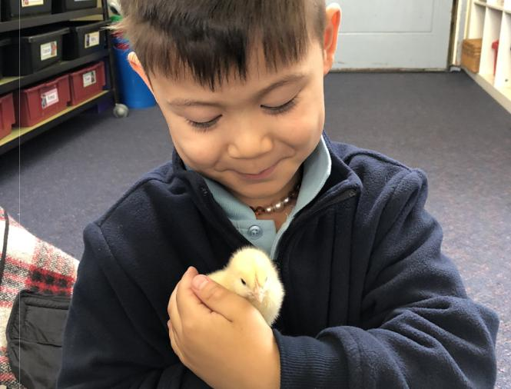
CSEF – Camps, Sports, and Excursion Fund

The Camps, Sports and Excursions Fund (CSEF) will provide payments for eligible students to attend camps, sports and excursions.

Families holding a valid concession card are eligible to apply. $125 per year is paid for eligible primary school students directly to the school and are linked to the student.

A CSEF application form will be sent home to each student at the start of Term 1. You can also see the office for a copy. Families eligible for CSEF also receive uniform.

MONEY SENT TO SCHOOL

It would be appreciated if the correct amount of money is sent to school in an envelope with your child’s name, grade, amount enclosed and reason for the money. If more than one child’s money is enclosed, please send a note to the other teacher to let them know, as this saves time and children missing lessons.

NEWSLETTER and NOTICES
Each fortnight our ‘News from the North’ newsletter is available via Sentral and the DNPS website. We encourage parents and carers to read the newsletter as it contains relevant information related to upcoming events at school, celebrates student learning and recognises students who have received awards.

Notices regarding excursions, incursions and other events will be communicated via Sentral or a hard copy brought home by your child.

GETTING TO AND FROM SCHOOL

Children driven to school can be dropped off or picked up in David Street or Cleeland Street. There is pedestrian access in both streets at the school crossing and also next to the school car park.

We recommend that children do not ride their bikes to school because of the busy roads around the school and because lack of storage facilities.

Parents are urged to ensure that if their child/ children walk to school, they use the School Crossing provided and supervised by City of Greater Dandenong Crossing Attendants.

For safety reasons, it is recommended that children are encouraged to walk in groups.

FOR SAFETY REASONS, NO PARENTS, CARERS OR CHILDREN SHOULD ENTER OR WALK THROUGH THE STAFF CAR PARK.

PLAYGROUND SUPERVISION BEFORE AND AFTER SCHOOL

Parents should be aware that playground supervision by teachers does not begin until 8:50 am each morning.

After school, playground supervision is only provided from 3:15 pm until 3:30 pm.

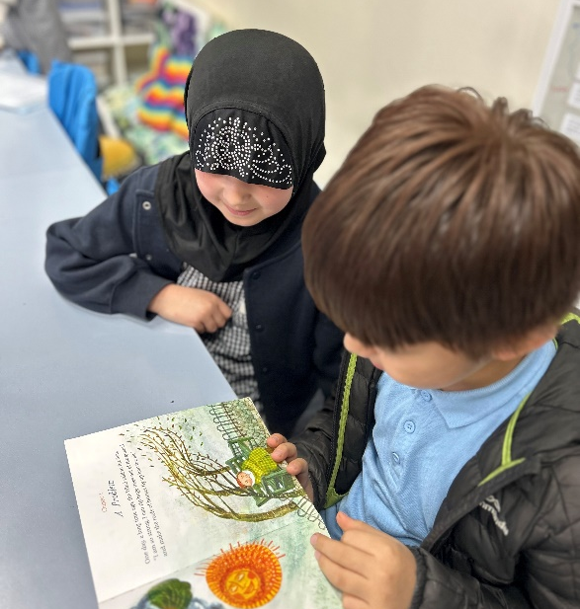

LATE ARRIVAL

If your child is late for school, please accompany them to the General Office for their late arrival to be recorded in our attendance data.

LEAVING SCHOOL EARLY

Children are not permitted to leave the school ground at anytime during the day.

Parents wishing to collect their child from school prior to 3:15 pm dismissal, must come to the office to collect an Early Lave pass. This must then be given to the teacher.
Children are not allowed to go home with older siblings or carers without a signed permission note from the parent explaining the reason.

At any time you require someone else to collect your child early from school, you will need to contact the General Office on 9794-7899, to let them know who is authorised to do so.

ABSENCE FROM SCHOOL

If your child is absent from school you must report this to the office via the Sentral App or a phone call/email to the office. If you have not recorded the absence or advised the Office by 9.30am, you will receive a text message/email/notification from the school on the day of their absence asking for an explanation.
It is unfair to the children and teachers to send a child who is obviously ill, or not fully recovered from illness, to school. Such children are not receptive to learning or to school routine and are better off at home until fully recovered.
The school also needs to be informed of planned and extended absences such as overseas trips. This can be done via the Sentral App or with a written note or email to the office or classroom teacher.

IMMUNISATION CERTIFICATE

The Victorian Health Act, state that all children at primary school will need to have an Immunisation Statement.

The Immunisation Statement is obtained from the Health Department or Medicare website, when your record of Immunisation or Statutory Declaration is presented.
The Immunisation Statement must be presented to the school whether your child has or has not been completely immunised.

This does not mean that your child has to be immunised. If your child cannot be immunised due to medical or conscientious reasons, the certificate will show that your child is not fully immunised. Health Department of Victoria recommends that all children are immunised against these diseases before they enter school.

HEAD LICE

Primary responsibility for head lice belongs to the family. Parents are obliged to inform the school if their child is infected with head lice. Principals are required to exclude students thought to be infected, until treatment is administered. Permission forms to examine your child for head lice will be provided upon enrolment. The school will inform parents if their child has head lice

ILLNESSES
Children should not be sent to school when they are ill, however, when a child becomes ill at school we place him/her in the Sick Bay and contact you, via your parent/ emergency details.
It is therefore important that the information we have is kept up to date.

INFECTIOUS DISEASES

During a child’s life at school it is possible that a child will contract some of the common diseases of childhood. The following table is binding on all doctors, teachers and parents.

DISEASE | EXCLUSIONS FROM SCHOOL
Chicken Pox | Exclude until all blisters have dried. This is usually at least 5 days after the rash appears in unimmunised children, but may be less in previously immunised children
Measles | Exclude for at least 4 days after onset of rash
Mumps | Exclude for 5 days or until swelling goes down (whichever is sooner)
Rubella  (German Measles) | Exclude until fully  recovered or for at least four days after the onset of rash
School Sores  (Impetigo) | Exclude until appropriate treatment has commenced. Sores on exposed surfaces must be covered with a watertight dressing.
Covid - 19 | Refer to DHHS guidelines

SCHOOL NURSING SERVICE

The School Nursing Service visits the school each year. The School Nurse will:

- Perform health assessments on all Prep grade children

- Assess/investigate, as appropriate, any children referred by teachers or parents because of suspected social, emotional, behavioural or physical problems

Monitor the progress of children for whom there were concerns during the last School Nurse visit
DENTAL HEALTH SERVICES

Dental Health Services are provided for primary school children and is staffed by Dentists, Dental Therapists and Dental Nurses.

Great importance is attached to the prevention of dental disease, through preventative procedures such as fissure sealants.

Additional dental care provided by the DET Dental Services includes: examinations, radiographs, if necessary, scaling and cleaning, fillings and extractions on both deciduous and permanent teeth.

The School Dental Van is located near the Emergency Department Entrance at the Dandenong Hospital in David Street. The telephone number is 9554-1085.

For further information contact:

Telephone: 1300 360 054

MEDICATION

There is a medication form that you can collect from the school nurse.

Medication is not given to children unless written authorisation is received from a doctor. This authorisation must include child’s name, medication to be taken and the time and dosage to be taken. All medication must be handed in at the general office, it will be safely stored in the sickbay.

MOBILE PHONES
Students are not encouraged to bring mobile phones to schools. If a parent has requested that their child needs a phone brought to school, it MUST be stored in the office from when they arrive at school until the end of the school day.

PRIVATE PROPERTY

Private property brought to school by students is not insured, nor is the Department of Education responsible for any loss. Children should therefore not bring valuable items to school.

UNIFORMS

Dandenong North Primary School uniform colours are navy blue tracksuit pants or shorts, light blue polo t-shirt and navy blue windcheater. All foundation students will be provided with a hat.

All students are expected to wear their uniform.

State Schools’ Relief (SSR) sell their own branded uniforms and 100% of the profits from the sales of their Student's Choice label are returned to the organisation to further benefit disadvantaged kids.

When purchasing items from State Schools’ Relief, this can be done quickly and easily via the Qkr App.
You can download the free Qkr App onto your Android or iPhone (iPad users can download the iPhone app).
Uniform items can be purchased and exchanged directly from our location during business hours.
Business hours: 8:30am to 4.30pm, Monday to Friday
Location: 1/8 Johnston Court, Dandenong South VIC 3175
Mailing address: PO Box 4528, Dandenong South VIC 3164
Phone: 03 8769 8400
Email: contact@ssr.net.au

SUN SMART

Our Sun Smart policy has been developed to ensure that all students and staff attending Dandenong North Primary School are protected from skin damage caused by the harmful ultra-violet rays of the sun. It is to be implemented throughout the year, but with particular emphasis in Terms 1 and 4.

As part of general Sun Smart strategies,

Dandenong North Primary School will:

- require all children to wear broad-brimmed hat whenever they are outside e.g. before/after school, morning recess, lunchtime, sport and excursions

- encourage all children to use available areas of shade for outdoor activities

ALL STUDENTS MUST WEAR BROAD-BRIMMED HATS IN TERM 1 AND TERM 4.

WELFARE
Dandenong North Primary School has a Welfare Officer to assist in any matter related to ensuring student wellbeing.

SPECIAL LUNCHES

During terms 2 & 3 a special lunch is organised as a special purpose fundraiser. Students will bring home a note in relation to this fundraiser/ special lunch, so that orders can be collected and processed.

SWIMMING PROGRAM

All children are given the opportunity to attend a two week swimming program each year. Children are encouraged to participate in this vital part of the school program. Further information regarding our swimming program will be sent out during term 3 of each year.
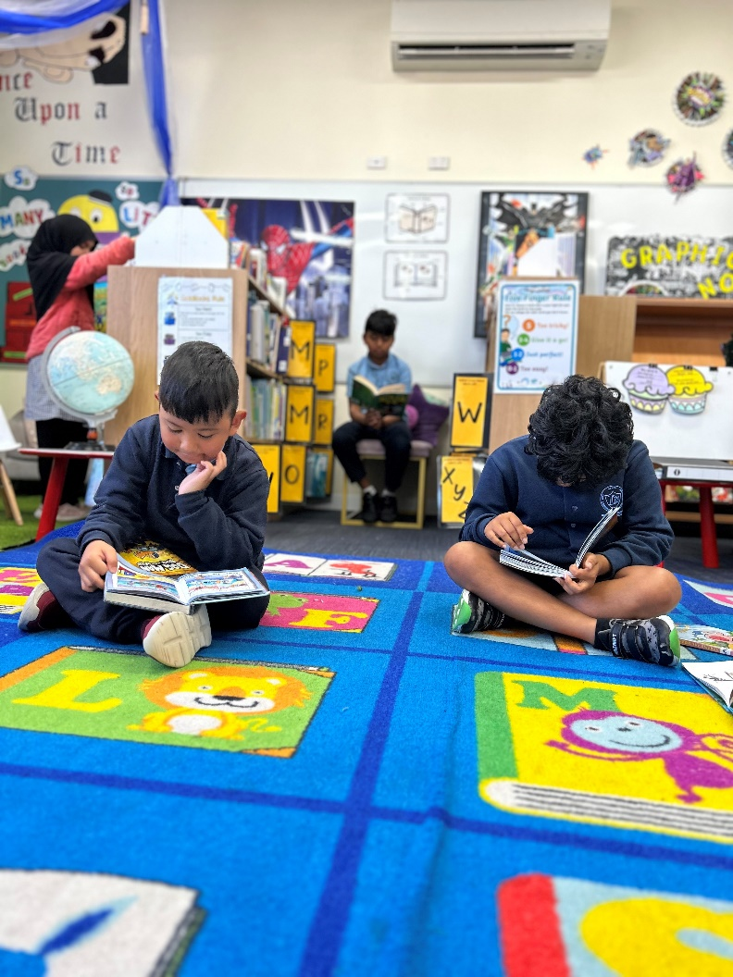
TRANSFERRING TO NEW SCHOOL

Parents are asked to notify the school office if their child is transferring to another school, during the year.

If your child is transferring at the end of the year (other than Year 6), you need to notify the school office so that transfer details can be sent to the new school.

ASSEMBLY ARRANGEMENTS

On Monday at 9:00 am, an assembly for the school is held in our school gym. Students are encouraged to conduct the assembly and a student co-ordinator is appointed to oversee the arrangements.

As part of our self-esteem program and positive approach to discipline, many student awards are presented. Parents are welcome to attend.

PARENT HELPERS

Over the years, parents have voluntarily assisted the school in hearing children read, helping on excursions, covering books and other numerous tasks. Requests for help either come directly from class teachers or via our newsletter. Your involvement in our school is appreciated and encouraged.

BOOKCLUB

During the year, students have the opportunity to order books for their personal home library. Order forms need to be returned to school with the correct money by the announced time. It usually takes about two weeks for the order to be delivered.

SCHOOL COUNCIL

The School Council initiates changes as a result of policy reviews, and looks after school finances, building grounds and fundraising.

All parents and teachers are eligible to stand for the school council and to vote at elections, keep in touch with the work of the school council; follow its plan and how it’s carrying them out; vote in the elections and consider standing for the council itself. The council makes decisions affecting your child and you.

It is benefit for the whole school that parents take a close interest in the work of the school council;

- Is the focal point for decision making on overall school policies;

- Is the governing body at the school;

- Is a representative body with a membership reflecting the important partnership between student, teacher and the home;

- Is accountable to the local school community.

- School Council meets at least eight times a year, usually on the last Monday of the month.



Membership:

3 teachers, including the Principal

5 parents as required other members can be co-opted by school council and have a special interest in the educational program of the school.

Elections for school council are held each year in March.

Parents are welcome to attend School Council meetings as observers.

Our School Councillors are as follows;
- Ann Scott ( President)
- Meliha Colakoglu
- Rowina Farrugia
- Amena Husaini
- Zulfa Soltani
- Sathishkumay Condran
- Kristie Miller ( Staff)
- Cameron Fenby (Staff)
- Erin Scott ( Staff)
- Paul Hilton ( Principal)

SELF-ESTEEM PROGRAM
We will implement a program that rewards children who demonstrate CARE, COURTESY, COMMON-SENSE and COOPERATION (4 C’s).

- Promising to CARE for your yourself, your fellow students, your family, your teachers and the reputation of our school.

- Demonstrating COURTESY at all times by using good manners.

- Being the best learner and team-member you can, by CO-OPERATING with staff, students, parents and visitors.

- Thinking carefully about the consequences of anything you say or do, to make sure that you are using what is called COMMON-SENSE.

Special Awards and School Spirit

Each week a student is chosen from each class to be the student of the week with an award to be presented at assembly. When deciding on the recipient of the award look to our school values of care, courtesy, common-sense and co-operation to help teachers come to their decision.
Class awards are a great way to encourage students and to show them we value the effort they put into being a great student who displays the values of our school.

At the end of a Term, a School Spirit Trophy will be presented to one of the award winners from F – 6 Areas of the school. The leadership team and Year level leaders will decide upon a worthy recipient of an overall prize who will receive a trophy and a poster to be displayed in the office.

Badges

An integral part of the self- esteem program is our badges program. Badges are given to all teachers to present as positive reinforcement and encouragement prizes to students.

At each Assembly students with badges are asked to stand up after we all sing a catchy badges song. Two winning numbers are chosen. The lucky students get to choose from a range of prizes.

Close encounters - Student Raffle Tickets Teachers can write raffle tickets for students demonstrating the 4 C’s in the playground. Students playing co-operatively and helping each other and can be rewarded with a raffle ticket.

The ticket-part that the student gets is handed to the class teacher. They stick these together and when the class reaches 25, they can trade these for a bag of Halal sweets.

The other end of the ticket gets collected and a raffle is drawn at assembly. A special winner from 3-6 and P-2 then chooses a present from the golden box.

House Points
Foundation to Year 6 are divided into four Houses – MARSH (Red), KEYS (yellow), VEREY (green) and LEED (blue). The houses are named after original members of school council.
Teachers are encouraged to give out house points to positively reinforce student behaviour.
At the end of the week, each room’s points are tallied on a 4, 3, 2 and 1 basis to find the winning house for the week. These totals are announced at Monday morning’s assembly.

End of Term Reward

The winning house will be given the opportunity to attend a special incursion or excursion as a reward for their hard work at the conclusion of each term. Permission forms will be handed out and prompt payment will ensure attendance.

Eyes, Ears, Hearts and Minds award

This is a “Paying Attention” award “Eyes, Ears and Hearts and Minds” award (This is an award suggested by the SRC and it has to do with students who are attentive, listening and well-intentioned – mostly in class.) This is a cloth badge that can be sewn or pinned to uniforms.

The staff member who nominates a student for this award will present the award to the student at an assembly.

Malone Medallion

This is an award to recognize effort, commitment, success and enthusiasm in sporting endeavours. Malone medallions will be presented at Monday Morning Assemblies.

STUDENT LEADERSHIP

At Dandenong North Primary School, the Year 6 students are provided with multiple leadership positions.

School Captain
Students’ self-nominate to be a school captain and after an initial 1 minute presentation to Year 5 teachers and the Principal, they are selected to present a speech to the whole school explaining why they should be next year’s school captain. There are two school captains selected and their roles are to run school assemblies, welcome visitors to the school and they are seen as the student face of our school.
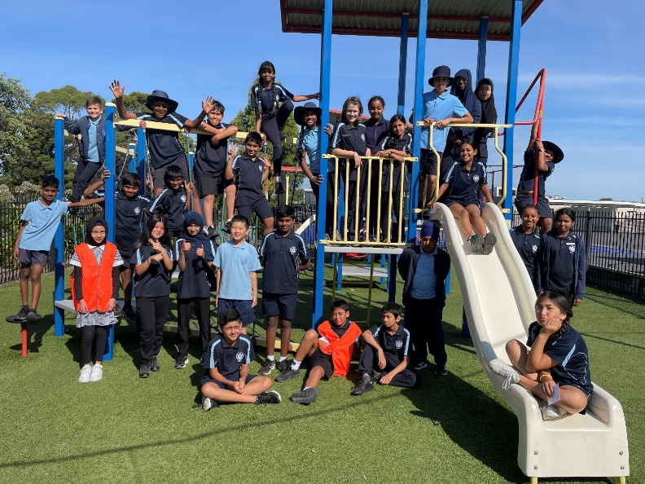
Leadership Team Member
These students nominate themselves to be a school captain and after being shortlisted to present at assembly and are unsuccessful, they then become a member of the school leadership team. Their roles are to support the School Captains with assemblies, the running of whole school events (eg Harmony Day) and showing visitors around the school.

SRC Leader
This student is also a member of the Student Leadership Team, however their role is focused around whole school events (such as Harmony Day) and fundraising campaigns (such as Cancer Council). They organise regular meetings with the students who are the representatives from each class in Years 3 to 6 to discuss future fundraising and provide student opinions to the Principal.

House and Vice-House Captains
Foundation to Year 6 students are divided into four houses. Marsh (red), Leed (blue), Keys (yellow), Verey (green). The houses are named after original members of school council.
The House Captains are elected by other Year 6 students. Their role is to take turns announcing the weekly house points at school assemblies and they assist the PE faculty.

Peer Mediators
Students nominate themselves to become a Peer Mediator and they are selected by the year 5 staff. These children undertake training and
are then seen in the yard at all break times, assisting students.

PAL (Peer Activity Leaders)
Students nominate themselves to become a PAL and they are selected to undertake training. During recess times twice a week, these students provide games in the gym for students in Foundation to Year 4 to attend and have some fun and make friends, playing structured games
